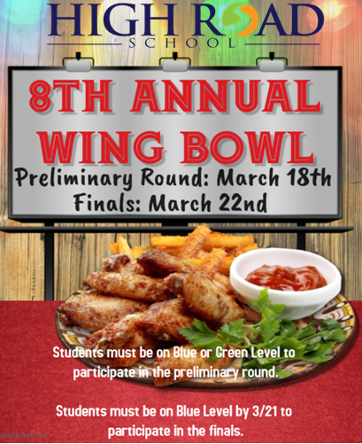
Permission Slip
In conjunction with our yearly March Madness Events, students are invited to participate in our annual wing bowl competition. Students who exhibit excellent academic and behavioral performance are eligible to participate in both their local school, and regional Wing Bowl Championships.
This form is intended to grant permission for your child to participate in the preliminary round on March 18th, 2019, at High Road School of New Castle County and the main event on March 22nd 2019, at High Road School of Cecil County.
Please return this slip before March 15th, 2019 in order
for your child to participate.

____ Yes, my child has permission to participate.

_____ No, my child may not participate.

Signature:____________________________________ Date: ______________

